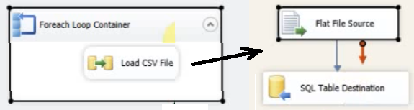

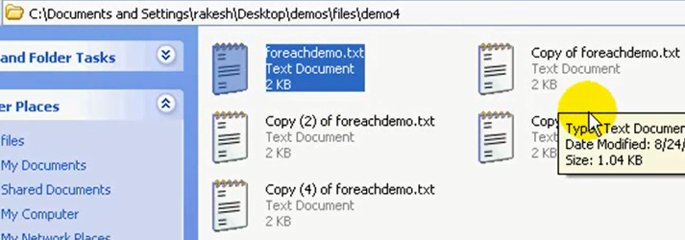

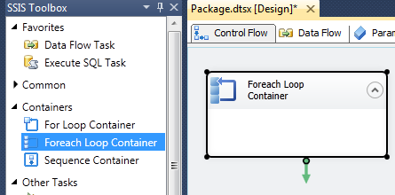

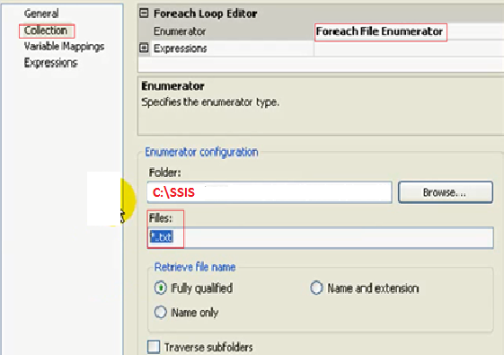

If check “Traverse subfolders” it will load also from sub folders

Now add variable filepath where the path for each file is going to be to change the connection string

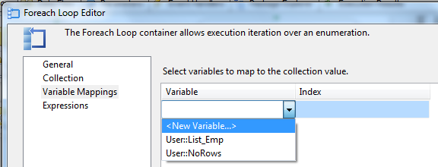

Add variable **filepath** where the path for each file is going to be to change the connection string

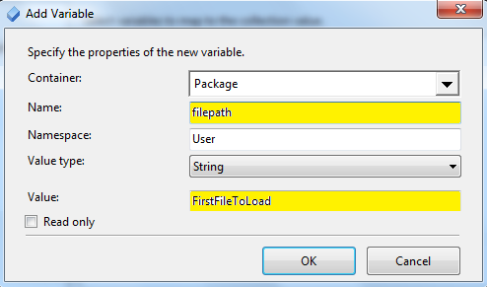

**Note: set the first load to be loaded, so you will be able to make the mapping**



Set Load CSV File: Source a Flat File

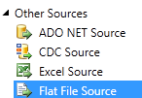

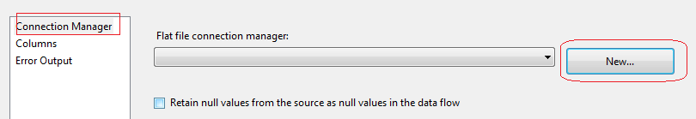

Set Connection Manager: **fileconn**

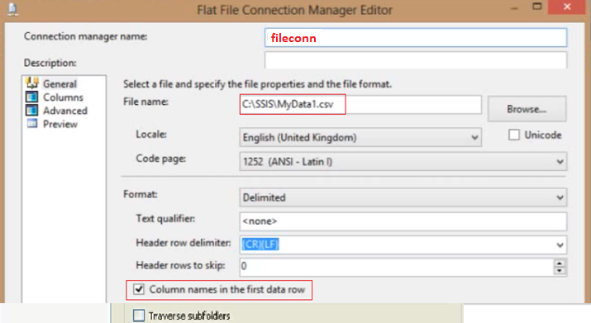

Set Columns:

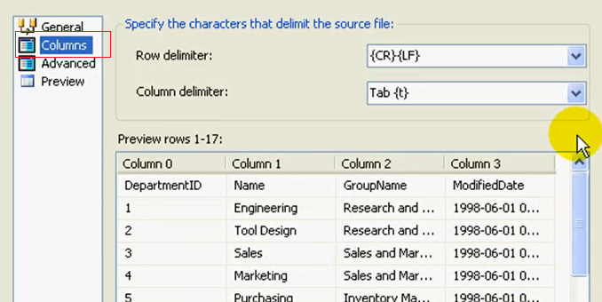

And Preview the data

Because we are loading different files, we must change the Connection every time, so

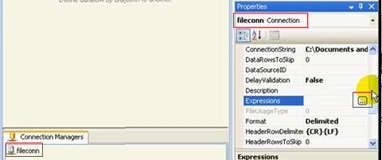

Set a variable named filepath where the path is:

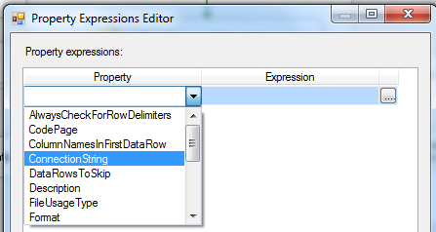

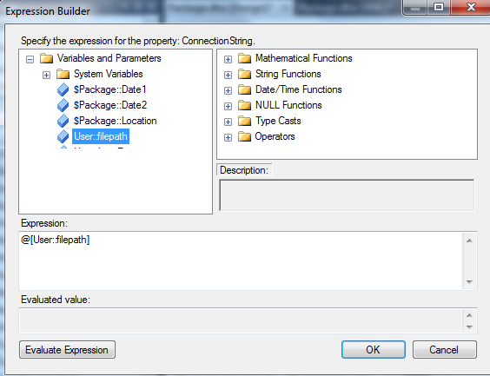

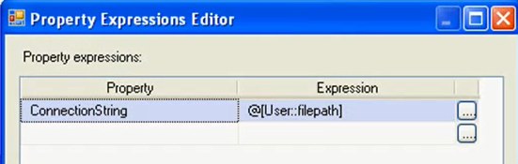

Now set the destination file and do the mapping

